42. Customer Segmentation: a) Load “customer_data.” file into a Pandas data frame, which

contains “Customer ID,” ”Age,” “Gender,” and “Total Spending.”

b) Segment customers into three groups based on their total spending: “High Spenders,” ”Medium Spenders,” and “Low Spenders.” Assign these segments to a new column in the data frame.

c) Calculate the average age of customers in each spending segment.

CODE:

import pandas as pd

df = pd.read_csv(r"C:\Users\jampa\OneDrive\文档\customer_data.csv")

quantiles = df['Total Spending'].quantile([0.33, 0.67])

df['Spending Segment'] = pd.cut(df['Total Spending'], bins=[-1, quantiles[0.33], quantiles[0.67], float('inf')],

labels=['Low Spenders', 'Medium Spenders', 'High Spenders'])

avg_age = df.groupby('Spending Segment')['Age'].mean()

print("Customer Segmentation:")

print(df[['Customer ID', 'Spending Segment']])

print("\nAverage Age per Spending Segment:")

print(avg_age)

print("\nData Quality Checks:")

df.info()

print("\nMissing Values:")

print(df.isna().sum())

print("\nGender Distribution:")

print(df['Gender'].value_counts())

print("\nSpending Segment Statistics:")

print(df.groupby('Spending Segment', observed=True)['Total Spending'].agg(['mean', 'median', 'std']))

OUTPUT:

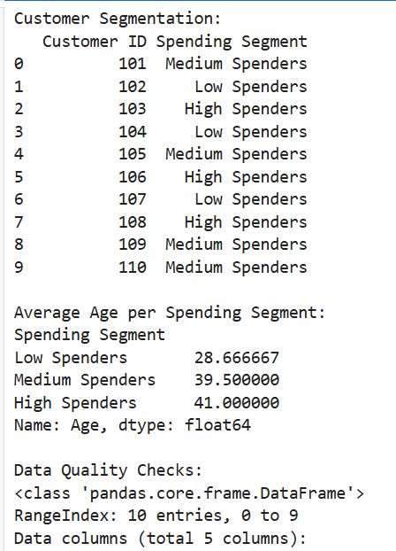

Dataset:

|  |  |  |  |  |
| --- | --- | --- | --- | --- |
| Customer ID | Age | Gender | Total Spending | |
| 101 | 25 | Male | 1200 |  |
| 102 | 34 | Female | 540 |  |
| 103 | 45 | Male | 3200 |  |
| 104 | 23 | Female | 300 |  |
| 105 | 52 | Male | 1500 |  |
| 106 | 37 | Female | 2300 |  |
| 107 | 29 | Female | 400 |  |
| 108 | 41 | Male | 2800 |  |
| 109 | 33 | Male | 950 |  |
| 110 | 48 | Female | 1600 |  |
|  |  |  |  |  |